The Path of Light
At amusement parks and carnivals, you’ll often find fun houses with curvy mirrors distorting your image. When you stand in front of them, you appear to be stretched really tall or squashed short. Fortunately, most mirrors aren’t designed to distort images this way. Normal mirrors reflect light off a flat surface so that the image is not distorted. Just how do mirrors reflect light to form normal-looking images? The answer may surprise you.



Law of Reflection
How do you use the law of reflection to interpret the light ray in this animation?
Is it possible to measure an angle of reflection? What would you need to know and do to measure this angle of reflection?

Video: How Reflection Works

Video features footage of a flashlight pointed at a mirror. When the flashlight is turned on, the light it produces hits the mirror at an angle (angle of incidence). The light is then reflected by the mirror at another angle (angle of reflection).

Angle of Incidence = Angle of Reflection

Example Problem: Angles of Reflection

Directions: View each step below in the example problem.

Reflection

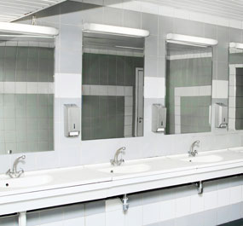
When light reflects off any smooth, shiny, polished, metal surface or mirror, there are two angles involved.

Mirrors in a restroom

Angle #1

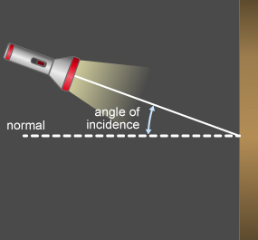
The first angle is the angle of incidence. It is the angle that the light ray makes with a line normal to the reflective surface. The “normal” is an imaginary line perpendicular to the surface.

A flashlight showing path of light onto a mirror. A perpendicular dotted line is labeled normal and the angle created from the beam and dotted line is labeled angle of incidence.

Angle #2

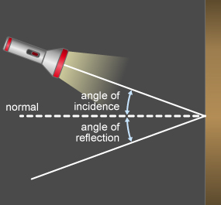
The second angle is the angle of reflection. This is the light ray that bounces off the mirror. This angle is also determined based on the same normal line that was used for the angle of incidence.

A flashlight showing path of light onto and reflected from a mirror. A perpendicular dotted line is labeled normal and the angle created from the beam and dotted line is labeled angle of incidence. The angle created from the reflected beam and the dotted line is labeled angle of reflection.

Measuring Angles

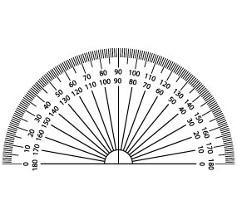
To measure an angle, you use a tool called a protractor—the tool seen here. Line up the normal line that is perpendicular with the reflective surface and the 90 degree line on the protractor. Read the number that corresponds to the line made by the light ray. This is the angle of that ray.

protractor

Investigation: Path of Light
What happens to a path of light when it hits a shiny surface, such as a mirror? Dakota is going to use these materials to map out a path of light.

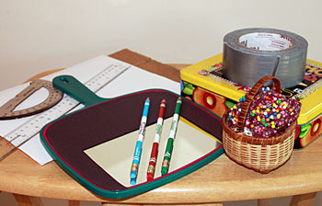

Time to Investigate
Follow along with Dakota as she traces the path that light follows.

Galleria

Step One
Image shown is a picture of the number one.

When Dakota looked for the materials to complete this investigation, she used a hand mirror and used black construction paper to cover the unused portion of the mirror. She used her mother’s box of stationary to support the mirror. She rolled pieces of duct tape to secure the mirror to the stationary box.

Step Two
Image shown is a picture of the number two.

She placed a piece of white paper on top of the corrugated cardboard. Holding it in a landscape orientation, Dakota then used the ruler and the red pencil to draw a line across the center of the paper.

Step Three
Image shown is a picture of the number three.

After securing the mirror to the stationary box, Dakota aligned the mirror along the red line she drew on the paper.

Step Four
Image shown is a picture of the number four.

Next, Dakota traced around the mirror and the stationary box to which it was attached to ensure the placement of the mirror remained the same throughout the investigation. She did notice that she had to adjust it periodically, especially after trying to place pins close to the mirror.

Step Five
Image shown is a picture of the number five.

Dakota then labeled the paper in front of the mirror as FRONT.

Step Six
Image shown is a picture of the number six.

She labeled the paper behind the mirror as BACK.

Step Seven
Image shown is a picture of the number seven.

Dakota then placed her first pin a few centimeters away from the mirror and near the right-hand edge of the paper. She made sure she could see the reflection of the pin just inside the edge of the mirror. She labeled this pin A.

Step Eight
Image shown is a picture of the number eight.

Dakota placed a second pin in the paper. This pin was 5 cm to the left of pin A and nearly touching the mirror. This pin she labeled B.

Step Nine
Image shown is a picture of the number nine.

Next, Dakota lowered her head so that she was looking into the mirror with one eye just above the paper from in front of the mirror. She looked at the image of the pins in the mirror and found the position where pin A and pin B seemed to line up in a straight line in the mirror (they looked like they were behind the mirror).

Step Ten
Image shown is a picture of the number ten.

She then placed a third and a fourth pin on the paper in front of the mirror so that they were in line with the images of pins A and B in the mirror. She attempted to place them about the same distance apart as A and B, but she knew that being close was fine. She could see that she could draw a straight line between the points to show the pathway of the light. Dakota labeled these pins C and D.

Step Eleven
Image shown is a picture of the number eleven.

Dakota next placed a pin about 3 centimeters to the left of pin B (facing the mirror) and made sure it was nearly touching the mirror, just like pin B. This pin, she labeled pin E.

Step Twelve
Image shown is a picture of the number twelve.

Again, Dakota lowered her head so that she was looking at the mirror with one eye just above the paper. She found the position where pins A and E seemed to line up in a straight line in the mirror (as though behind the mirror). She then placed another two pins on the paper so they lined up with the images of pins A and E in the mirror and about the same distance apart as pins A and E.

Step Thirteen
Image shown is a picture of the number thirteen.

However, as before, she knew not to be too concerned about the exact locations or spacing of the pins as long as she could draw a straight line through them to represent the path of the light. Dakota labeled these pins F and G.

Step Fourteen
Image shown is a picture of the number fourteen.

Since the investigation called for a total of three trials, Dakota repeated this process two more times, each time using a new piece of paper.

The Investigation Continues
Dakota continued her investigation by following these steps to figure out how a plane mirror affects the path of light.

Galleria

Step One
Image shown is a picture of the number one.

Dakota removed the mirror and the support system. As she removed each pin, she used a colored pencil to mark the hole it came out of. This was important because in some cases, Dakota had to realign pins C, D, F, and G to get the straight line she was looking for.

Step Two
Image shown is a picture of the number two.

Dakota used a ruler to draw a line connecting points A and B, extending it to the mirror line. She drew a line connecting points C and D and the mirror line. In this trial they did intersect, but in other trials they didn’t. So for those she extended the lines to a point at which they did. When she did have to extend the line, this point ended up slightly behind the mirror line (near point B).

Step Three
Image shown is a picture of the number three.

Dakota then followed the same steps for points A and E and points F and G. She made sure that their lines intersected at or near the mirror line (near point E).

Step Four
Image shown is a picture of the number four.

Dakota then extend the line made by connecting C and D and the line made by connecting F and G so that these two lines intersected. She found that they intersected on the portion of the paper that was behind the mirror. She labeled the point where the lines intersected as X.

Step Five
Image shown is a picture of the number five.

Using a protractor, Dakota drew a line perpendicular to the mirror line (90°), through the point where the first pair of lines intersected at or near the mirror line (near B).

Step Six
Image shown is a picture of the number six.

Dakota drew another line perpendicular to the mirror line (90°), through the point where the second pair of lines intersected at or near the mirror line (near E).

Step Seven
Image shown is a picture of the number seven.

Dakota used a protractor to measure the angle between the perpendicular line through the mirror line near point B and the line segment connecting A and B. She recorded this angle as trial 1, angle 1 in the data table. She also measured the angle between the perpendicular line through the mirror line near point B and the line segment connecting C and D. This she recorded as trial 1, angle 2.

Step Eight
Image shown is a picture of the number eight.

Dakota the measured the angles between the perpendicular line through the mirror line near point E and the line segments made by connecting A and E, as well as that connecting F and G. She recorded these angles as trial 1, angle 3 and angle 4 in the data table.

Step Nine
Image shown is a picture of the number nine.

Next, Dakota drew a line connecting point A and point X. She made sure that she used the ruler to measure the distance between point A and the mirror line, along the line you just drew. She recorded this distance in the data table as trial 1.

Step Ten
Image shown is a picture of the number ten.

Dakota also measured the distance between the mirror line and point X using the ruler. She recorded this distance in the data table as trial 1.

Trial 2 and Trial 3
Dakota repeated the procedure steps to complete two more trials for the investigation. Here are the results of those two trials.

Galleria

Step One
Image shown is a picture of the number one.

Dakota followed the same procedures to place the pins in Trial #2 and to draw the lines.

Step Two
Image shown is a picture of the number two.

Dakota then used the protractor to measure the angle between the perpendicular line through the mirror line near point B and the line segment connecting A and B. She recorded this angle as trial 2, angle 1 in the data table. She also measured the angle between the perpendicular line through the mirror line near point B and the line segment connecting C and D. This she recorded as trial 2, angle 2.

Step Three
Image shown is a picture of the number three.

Dakota then measured the angles between the perpendicular line through the mirror line near point E and the line segments made by connecting A and E, as well as that connecting F and G. She recorded these angles as trial 2, angle 3 and angle 4 in the data table.

Step Four
Image shown is a picture of the number four.

Next, Dakota drew a line connecting point A and point X. She made sure that she used the ruler to measure the distance between point A and the mirror line, along the line you just drew. She recorded this distance in the data table as trial 2.

Step Five
Image shown is a picture of the number five.

Dakota also measured the distance between the mirror line and point X using the ruler. She recorded this distance in the data table as trial 2.

Step Six
Image shown is a picture of the number six.

Dakota followed the same procedures to place the pins in Trial #3 and to draw the lines.

Step Seven
Image shown is a picture of the number seven.

Dakota then used the protractor to measure the angle between the perpendicular line through the mirror line near point B and the line segment connecting A and B. She recorded this angle as trial 3, angle 1 in the data. She also measured the angle between the perpendicular line through the mirror line near point B and the line segment connecting C and D. This she recorded as trial 3, angle 2.

Step Eight
Image shown is a picture of the number eight.

Dakota then measured the angles between the perpendicular line through the mirror line near point E and the line segments made by connecting A and E, as well as that connecting F and G. She recorded these angles as trial 3, angle 3 and angle 4 in the data table.

Step Nine
Image shown is a picture of the number nine.

Next, Dakota drew a line connecting point A and point X. She made sure that she used the ruler to measure the distance between point A and the mirror line, along the line you just drew. She recorded this distance in the data table as trial 3.

Step Ten
Image shown is a picture of the number ten.

Dakota also measured the distance between the mirror line and point X using the ruler. She recorded this distance in the data table as trial 3.

Study Club: Path of Light and Plane Mirror

Screen 1

The Data

Trial | Angle 1 (degrees) | Angle 2 (degrees) | Angle 3 (degrees) | Angle 4 (degrees) | Distance from A to mirror (cm) | Distance from X to mirror (cm)
1 | 29 | 34 | 19 | 23 | 2.9 | 2.8
2 | 29 | 30 | 19 | 19 | 3.0 | 2.9
3 | 32 | 29 | 23 | 20 | 3.4 | 3.5

Dakota: This is what my completed data table looked like. I know that the angle of incidence equals the angle of refraction, but not all my results proved this. The results in trial #2 came the closest to proving this theory. I found it difficult to place the pins in an exact straight line, so I’m sure this caused some experimental error. While this was a challenging investigation, and I didn’t get perfect results, it did help me to understand the path of light in a plane mirror.
Assignment: Plane Mirror Investigation
Use the observations to answer the questions in this assignment.

